Linux Package Management

APT Installing Packages Exercise
Lets install some software. Below we have identified some packages that are available from the default Debian package repository. Your task is to install the software and provide some screenshots of the software running in virtual box.

Abes Amazing Adventure
Description | sudo apt show abe  A scrolling, platform-jumping, key-collecting, ancient pyramid exploring game, vaguely in the style of similar games for the Commodore+4. The game is intended to show young people all the cool games they missed.
command | sudo apt install abe
Repository url | http://ftp.debian.org/debian/pool/main/a/abe/
screenshot | 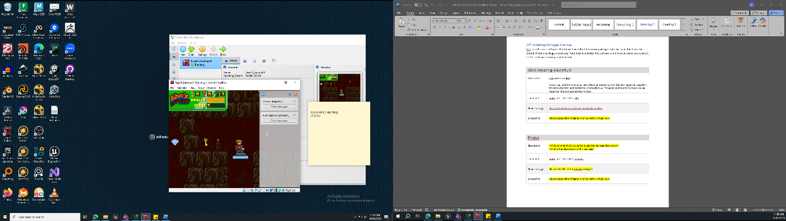

Pingus
description | Sudo apt show pingus  Pingus is a free clone of the popular Lemmings game.  Your goal is to guide a horde of penguins through a world full of obstacles  and penguin traps to safety. Although penguins (unlike lemmings) are rather  smart, they sometimes lack the necessary overview and now rely on you to  save them.
command | sudo apt install pingus
Repository url | https://ftp.debian.org/debian/pool/main/p/pingus/
screenshot | 